Contracting Out and Privatization workshop
CUPE Ontario Spring School
Held in Toronto from February 24th to Sunday, March 1st, 2015

COPE 491 paid my registration fee to participate in the workshop "Contracting Out and Privatization", I took two vacation days because the current Director of CUPE Ontario Regional Office did not approve the days off with pay that I needed, it was denied arguing that Section 16.14 of our Collective Agreement does not applicable to my request. I tried to save $100 of the registration fee thinking that our union is affiliated to CUPE Ontario Division but we are not so we had to add that extra amount. The purpose of my participation in this workshop is in preparation for my retirement because I plan to continue being active in the labour movement, protecting worker's rights and I truly believe there is a role we can play in favor of our communities at large. After taking this workshop I was wrong and it is very useful before.
Ninety-nine percent of participants in the workshop were CUPE members who are working in the Municipality sector across the province, 17 brothers and 1 sister. We had two instructors: a CUPE Servicing Representative and an outside consultant with long experience training union members. The teaching methodology they applied was of a participatory nature, lot of role playing opportunities complemented with written materials and videos based on real situations.
I think this training is very comprehensive and effective because it covers all aspects to be considered when organizing, implementing and evaluating a full campaign not just against contracting out and privatization of public services, it can be applied to any other campaign. Participants had the opportunity to understand the problematic and its negative impact to members if nothing is done.
The training was very effective because members had the opportunity to play a role during each step of a campaign. Learning by doing was very effective. For instance, when launching a campaign, participants had to choose the slogan they are going to use during the campaign and prepare the communication material to launch the campaign and involve the community at large. Participants learned even how to design their campaign logo. It is the best tool for attendants to remember what involves such task. The same approach is applicable to other situations when facing roadblocks with the employer.
I finally found the purpose of my participation and I think I will be lobbying as a retired citizen in support of the labour movement, locals need to be properly informed so they can take an informed decision and to identify key people that are ready to support them that would help them to strategically position themselves protecting their jobs. What is also good to know is that the workshops prepares COPE 491 member for any campaign we may get involved that will strengthen our ability to negotiate, to act and to achieve goals in favor of our membership. One our sisters questioned my participation to this workshop and now more than ever I assert she is wrong and perhaps her lack of information and understanding of the importance of the membership to be educated.
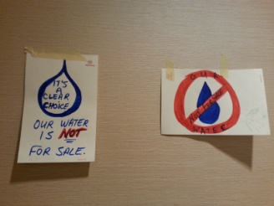 | 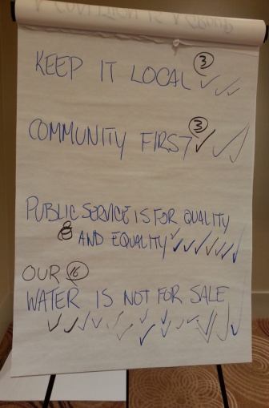
Logo | Slogan

What I found so surprising is how much COPE491 members can contribute to the training; somehow we know what is happening and what it is needed to be done. At the beginning my approach was to observe and learn and avoid active participation because the training was addressed to CUPE members but at certain point I had to participate due to its participatory process. For instance, we were asked to propose two slogan for a campaign, I proposed the slogans "COMUNITY FIRST" and "OUR WATER IS NOT FOR SALE", all the participants went to the process of eliminating so many slogan to end with 4 slogan and those two that I proposed were the most popular and the majority of participants voted for one of my proposal. When we were doing this exercise I thought about my experience working as a clerical for the Communications team at ORO office.
During the role playing process, we had the opportunity to hold a general membership meeting, to organize a rally and a town hall with the community (all pretending) and we had meeting with the management and he mayor of the city that was trying to contract out water services. I wanted to play the role of a community member so I can appreciate the interaction of a Union and the community but there was not enough time to do so. Instead I was appointed a CUPE National Representative for the Local. It was a surprise to learn the apathy that some CUPE members have towards CUPE Staff Representative and the Legal Team. Some of them were complaining they do not too much and take forever for our lawyers to take on a case. Obviously I just listened and kept a positive mind to contributing to the development of the campaign. I realized that to organize a campaign is not so easy as it looks, it requires of lot of work, time dedication and resources. If the Executive of a Local does not have a strong leadership their campaign may fail.
The workshop is excellent and I highly recommend COPE491 members to take it, it is an opportunity to learn and to apply to any opportunity that our Union has. Besides that I had the privilege to get to know CUPE leaders who fight for their members' rights and benefits. It was a real treat for me to get to know them. I regret there were not enough female members and I wonder if this aspect has been neglected.

