Julie Fenton
CLC SUMMER SCHOOL REPORT
FACING MANAGEMENT EFFECTIVELY
1-WEEK WORKSHOP - JUNE 5-10, 2015

I decided to drive to Port Elgin as I had done in the past, to appreciate the scenic route and also to avoid the chaos surrounding Toronto and the Pan Am games during that period. On the return trip as well, I was able to process my week at Port Elgin UNIFOR Education Centre, and the wonderful learning experience attained, the camaraderie and friendships made, and the solidarity built during one week.
Dan Oldfield and Barbara Saxberg, our facilitators, as well as partners in life, were extremely informative, energetic, and engaging the entire week. Their past experience and their sense of humour was much appreciated and allowed us to learn and de-stress from our own stories of facing frustrations with management. Icebreaker exercise had us draw an Avatar of our thoughts – I drew a dog – dogs are easy to work with, train, and love – if only people were the same.
There was much role playing in this class from day-one! At one point through the week we all had to play a role as management, or union committee representative, with many scenarios to work with. It was very difficult to wear a different hat at playing the role of management as we talk, think, and are UNION members!
Many tools at our disposition can be to our benefit if we can learn and control how we use them, i.e. how to fact-find information from all angles, how to read characteristics and body language to your advantage, how to build positive relationships, to use positive words such as <Yes, and…> rather than <Yes, but…>, to work on good communications to find common goals, so that in the end you find a process for reaching an agreement.
I found that exercises were too full of possibilities, making non-facts hard to work with; mention was made to the facilitators who will rework this ‘new’ workshop. We also mentioned that more examples of past experiences could teach us more and be more valuable compared with doing imaginary exercises.
We were expecting Sid Ryan, CUPE Ontario, to speak at the opening on Sunday, but he had to cancel. I don’t recall the names, but one Aboriginal woman from a nearby community and also a woman in a political role gave speeches. I missed the first part, but much emphasis was made about the upcoming elections and the possibilities of having an NDP in power. Promotional materials were also available to bring back to our Local and members. Barbara Byers, CLC Secretary-Treasurer, was one of the judges at the Thursday talent show, as well as gave an inspiring speech at the closing about the upcoming elections and how the NDP is running a tight race and could possibly be our next leader if we could encourage people to talk about the NDP platform and to encourage people to go vote. We need to put the message out there.
…/2
- 2 -

There were plenty of opportunities to socialize and speak with people from other unions. There was a Bocci Ball competition, a social evening at a local bar, the beautiful beach and her sunsets on Lake Huron, lots of sports equipment available to everyone, a program for childcare, a program for teens, certainly no lack of things to do. The buffet-type dining lounge provided three home-made meals per day. The rooms were extremely clean, comfortable and spacious.
I thank COPE and the CLC for providing this opportunity. The CLC staff were very accommodating and they paid attention to every detail. I intend to promote union education to our cope491 members as I believe it encourages solidarity; I hope to promote the message that unions are there to protect rights and benefits, and to convince that unions should continue with a collective agreement with all.
Respectfully submitted,
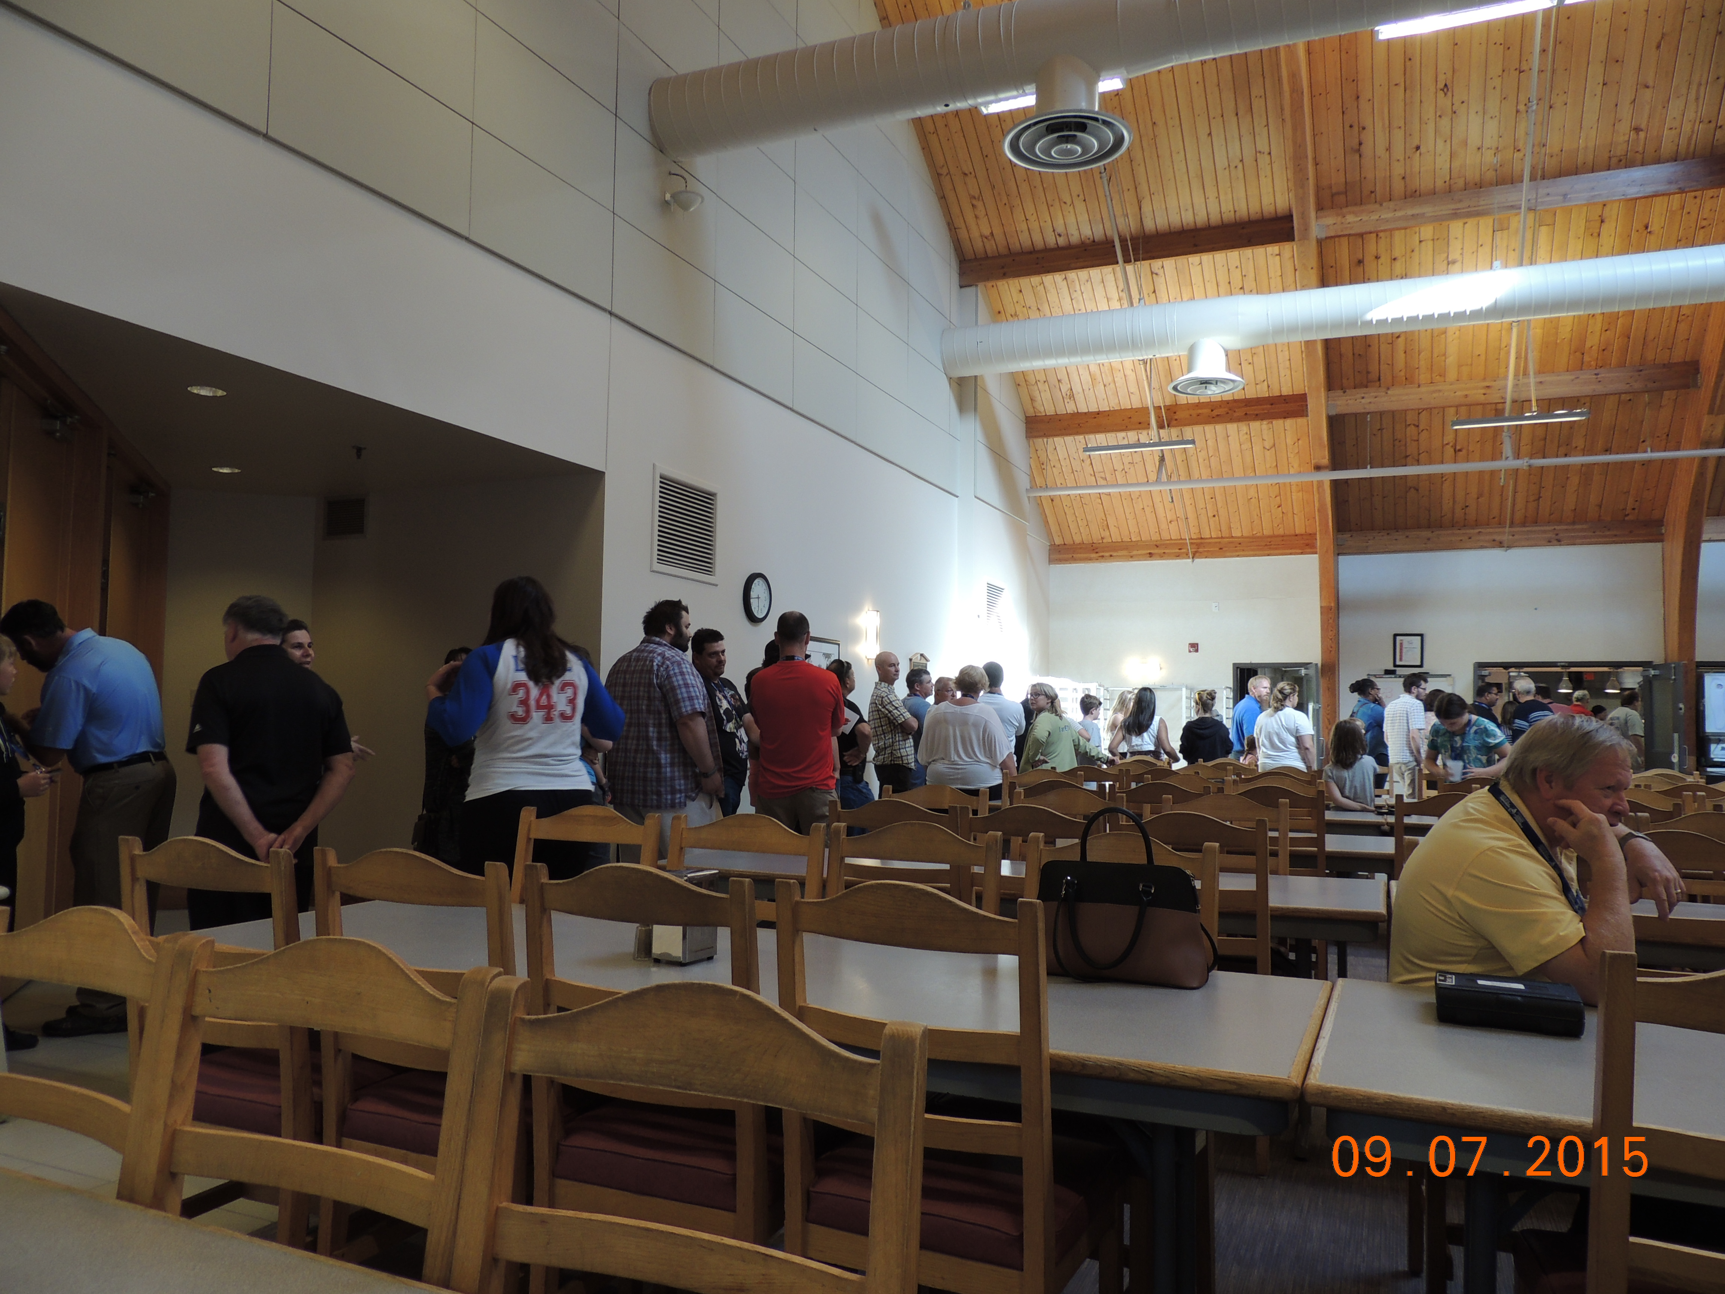

Julie Fenton,
COPE 491
CUPE National Office

UNIFOR CENTRE – DINING ROOM
References:
Facing Management Effectively: Participant workbook (CLC)
Blueprint for a Breakthrough: https://www.youtube.com/watch?v=aV805a2XJgA
Dan Oldfield - Barbara Saxberg website: http://www.szg.ca/podcast.html
Facebook page: www.facebook.com/CLCOntario

Movies:
Made in Dagenham Pay Equity story
Steve Jobs – The man in the machine Communication strategies for this workshop

Jf-cope 491
Workshops’ Talent Show
Thursday – 7:00 pm
Facing Management Effectively
SONG: Donna Summer – She works hard for the money.

- CHORUS (sung by union)
We work hard for the money
So hard for it honey
We work hard for the money
But they never treat us right?

Nine am on the hour-hand
Workers waiting for the bell
Will we get a deal
Only time will tell

Spent a lot of time on strategies
To make them treat us right
Bosses stonewalling
All the way through the night

- CHORUS (union - repeat twice)

Twenty-eight contract come and gone
And we’ve seen a lot of tears
Thousand walked the lines
No need for us to go here

Plenty of common ground
Justice is all it takes
And it’s worth it all
Just to give the bosses a shake

- CHORUS sung by Management
You work hard for the money
So hard for the money
You work hard for the money
So we’re gonna treat you right!

